**FINAL GRAMMAR REVIEW**

**Scroll down for answers.**

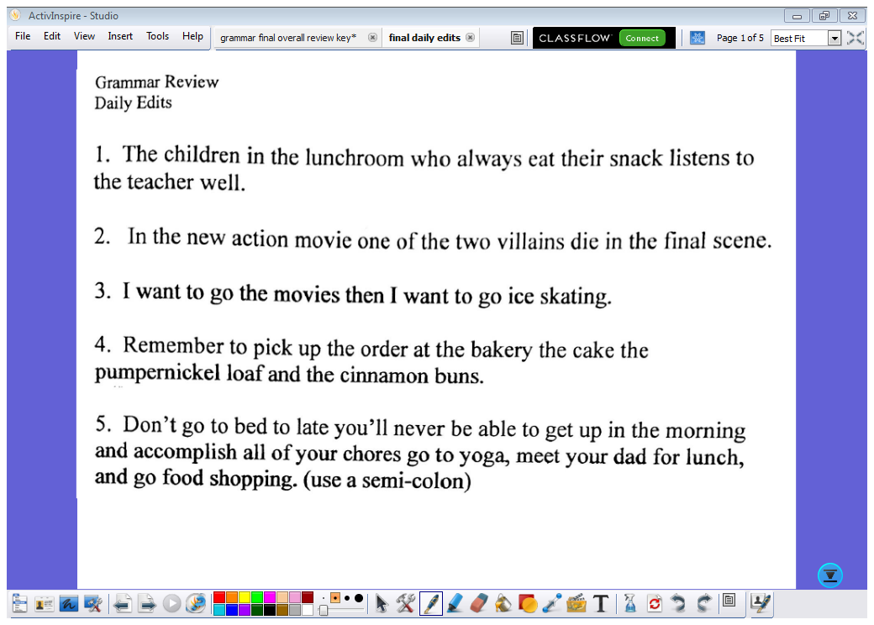

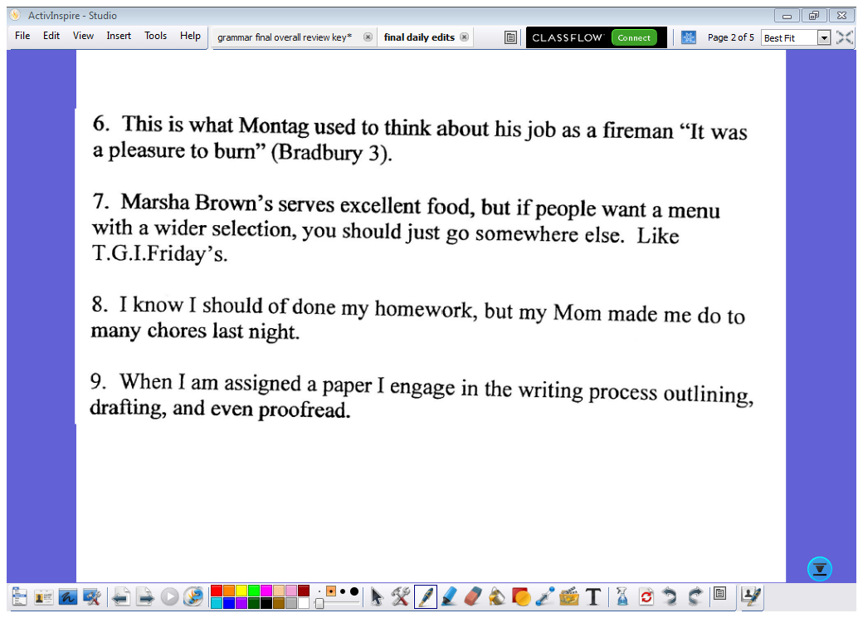

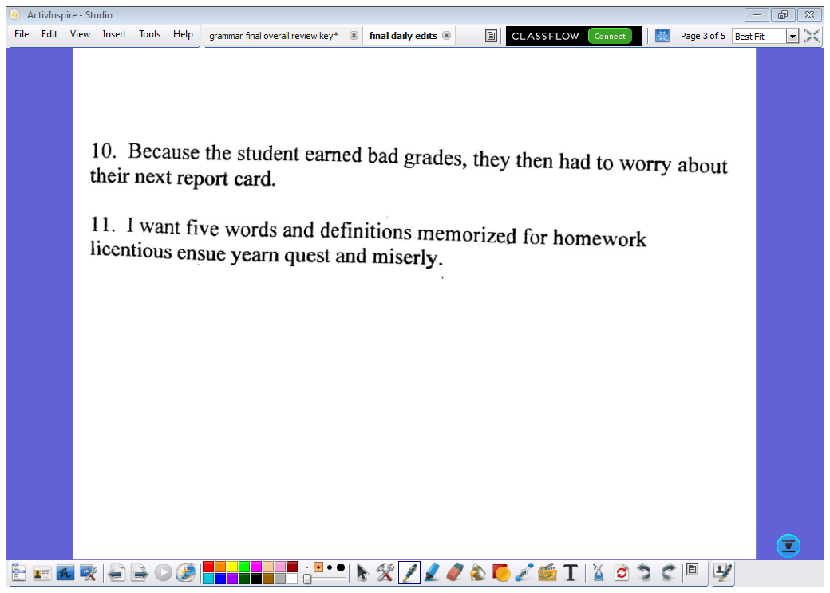

12. I think that this summer I will go water skiing, hang out at the beach, and surf.

13. The principal could see that one of the two students chew gum and then stick it under the desk.

14. Do you go to visit your Uncle each week at the nursing home he would really like the company.

15. The alien, exhausted after his crash to Earth, couldn’t restart their ship again.

16. Of Mice and Men is a touching book, it really makes you think about loyalty and friendship.

17. If only I had studied for my final exam, I could of passed the course.

18. The professors who are visiting from the college near the city explains what it’s like to attend a university.

**ANSWERS:**

Note #9—“proofreading” is required for parallel structure

Note #15: his/her could work if the alien had a clear sex

